Docker — Three-Tier Architecture:
- Deploy a three-tier application using Docker Compose: Frontend (Nginx/React) → Backend API → Database (choose MySQL or PostgreSQL).
- Configure Docker networks, persistent volumes, health checks, environment variables, restart policies, and service dependencies. Expose only the frontend externally. Demonstrate how you would troubleshoot frontend → backend and backend → database connectivity issues.
Implementation: -
Here I am using as Docker Three-Tier web Application (Frontend → Backend API → PostgreSQL).
Yes. You can implement the same three-tier architecture without Docker Compose by creating and managing each container manually using docker network, docker volume, and docker run commands.
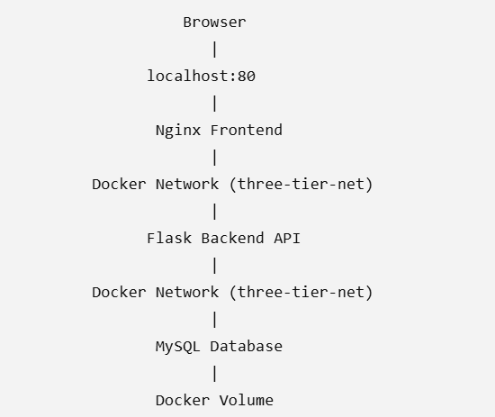
#Here only Nginx will be exposed
A-Create Docker Network
#creating docker network “three-tier-net” as above
$docker create network three-tier-net
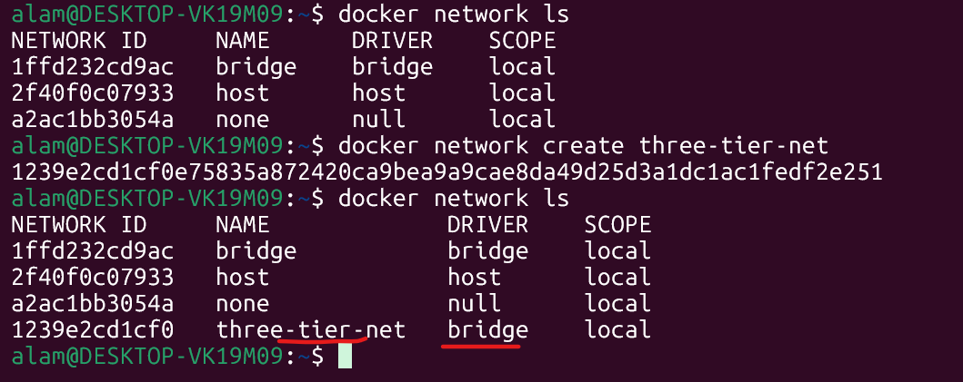
B-Create Persistent volume
$docker volume create mysql-data
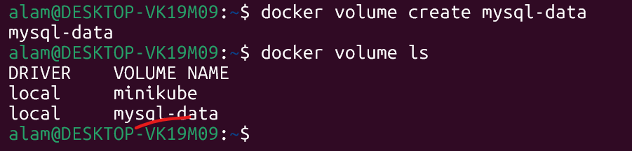
C- Run MySQL Container
$ docker run -d --name mysql-db --network three-tier-net -v mysql-data:/var/lib/mysql -e MYSQL_ROOT_PASSWORD=root123 -e MYSQL_DATABASE=employee_db -e MYSQL_USER=admin -e MYSQL_PASSWORD=admin123 --restart unless-stopped mysql:8.0
MYSQL_USER=admin -e
PASSWORD=admin123
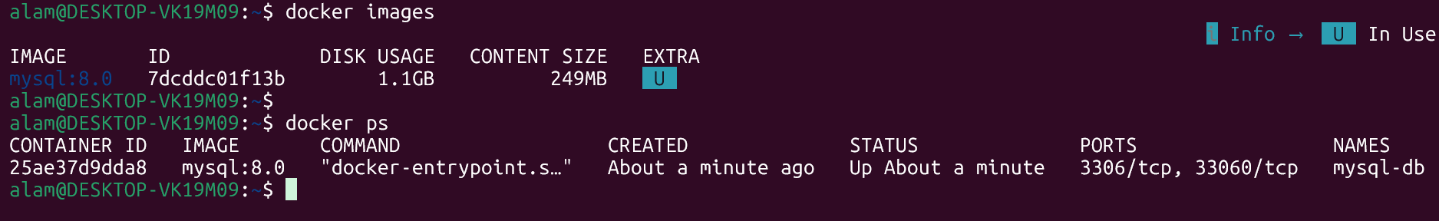
D - Backend Application

#/home/alam/three-tier-app/backend/app.py
from flask import Flask
import mysql.connector
import os

app = Flask(__name__)

db = mysql.connector.connect(
host=os.getenv("DB_HOST"),
user=os.getenv("DB_USER"),
password=os.getenv("DB_PASSWORD"),
database=os.getenv("DB_NAME")
)

@app.route("/")
def home():
return "Backend Connected Successfully!"

@app.route("/db")
def dbcheck():
cursor = db.cursor()
cursor.execute("SELECT DATABASE();")
return cursor.fetchone()[0]

app.run(host="0.0.0.0", port=5000)

# /home/alam/three-tier-app/backend/requirements.txt
# requirements.txt
flask mysql-connector-python

Backend Dockerfile
# /home/alam/three-tier-app/backend/ Dockerfile
FROM python:3.11-slim

WORKDIR /app

COPY requirements.txt .

RUN pip install --no-cache-dir -r requirements.txt

COPY . .

EXPOSE 5000

CMD ["python","app.py"]

E-Build Backend Image
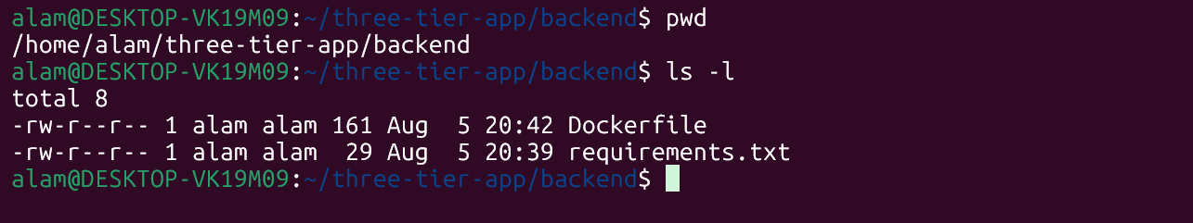# docker build -t flask-backend:v1 .

F- Run Backend Container
docker run -d \ --name backend-api \ --network three-tier-net \ -e DB_HOST=mysql-db \ -e DB_USER=admin \ -e DB_PASSWORD=admin123 \ -e DB_NAME=employee_db \ --restart unless-stopped \ flask-backend:v1
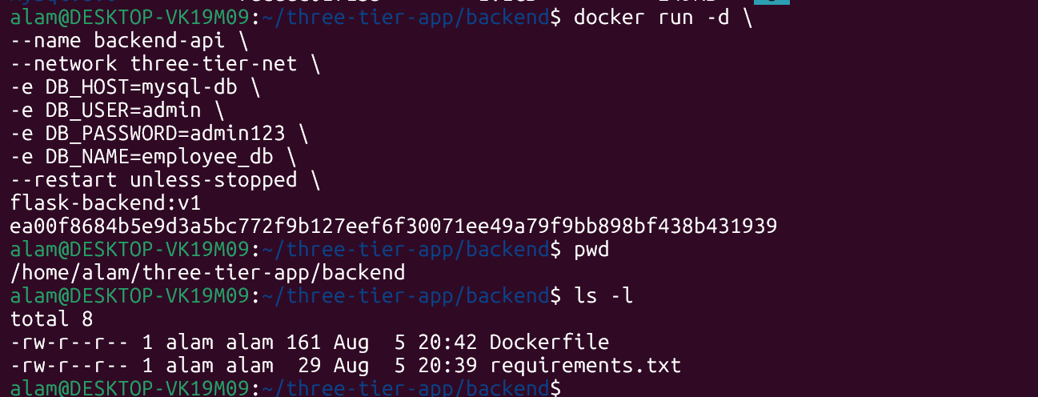

G- Frontend --inside fronted dir
Index.html
<!DOCTYPE html>

<html>
<head>
<title>Three Tier App</title>
</head>

<body>

<h1>Docker Three Tier Application</h1>

<button onclick="load()">Connect Backend</button>

<p id="result"></p>

<script src="script.js"></script>

</body>
</html>

script.js -- inside fronted dir
async function load(){

const response = await fetch("/api");

const data = await response.text();

document.getElementById("result").innerHTML=data;

}

nginx.conf --- inside fromtend dir
events {}

http {

server {

listen 80;

location / {

root /usr/share/nginx/html;

index index.html;

}

location /api {

proxy_pass http://backend-api:5000;

}
}
}

Frontend Dockerfile
Dockerfile -- inside the frontend file

FROM nginx:latest
COPY index.html /usr/share/nginx/html/
COPY script.js /usr/share/nginx/html/
COPY nginx.conf /etc/nginx/nginx.conf

#cd frontend
# docker build -t nginx-frontend:v1 . --- frontend image building in progress
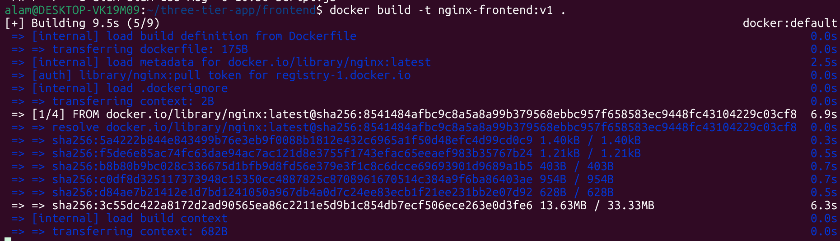
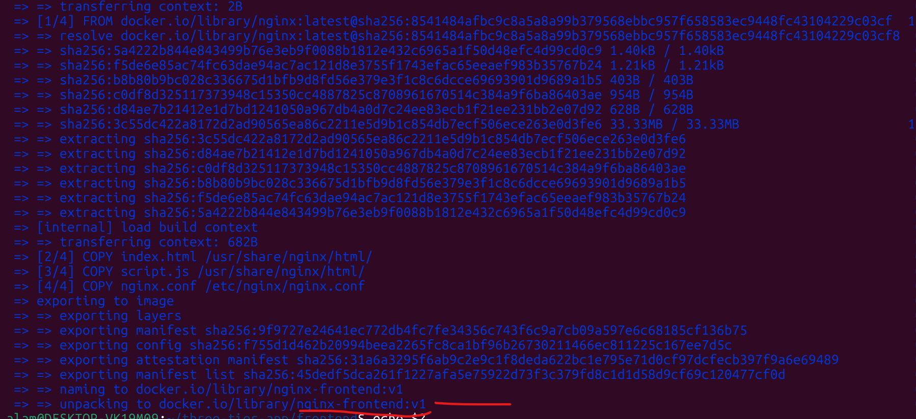
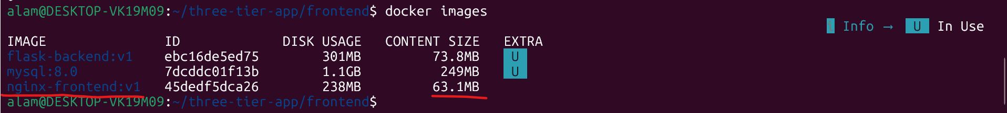

H - Step 9 Run Frontend Container - from above created nginx-frontend:v1 image
# docker run -d --name frontend --network three-tier-net -p 80:80 --restart unless-stopped nginx-frontend:v1
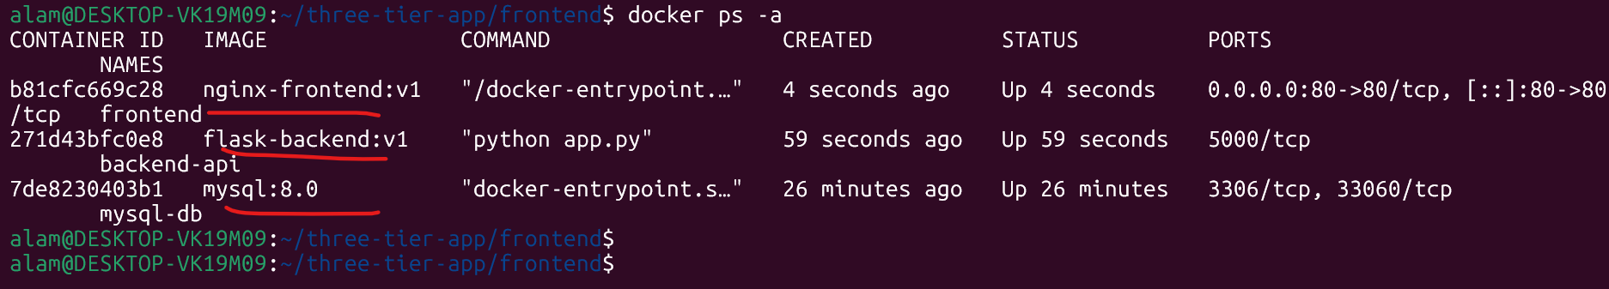
Note: Here only port 80 is open for public. Backend DB remain private
Architecture
Frontend http://backend-api:5000 Backend mysql-db:3306 Database
I – Network check and connectivity
$ docker network inspect three-tier-net ----
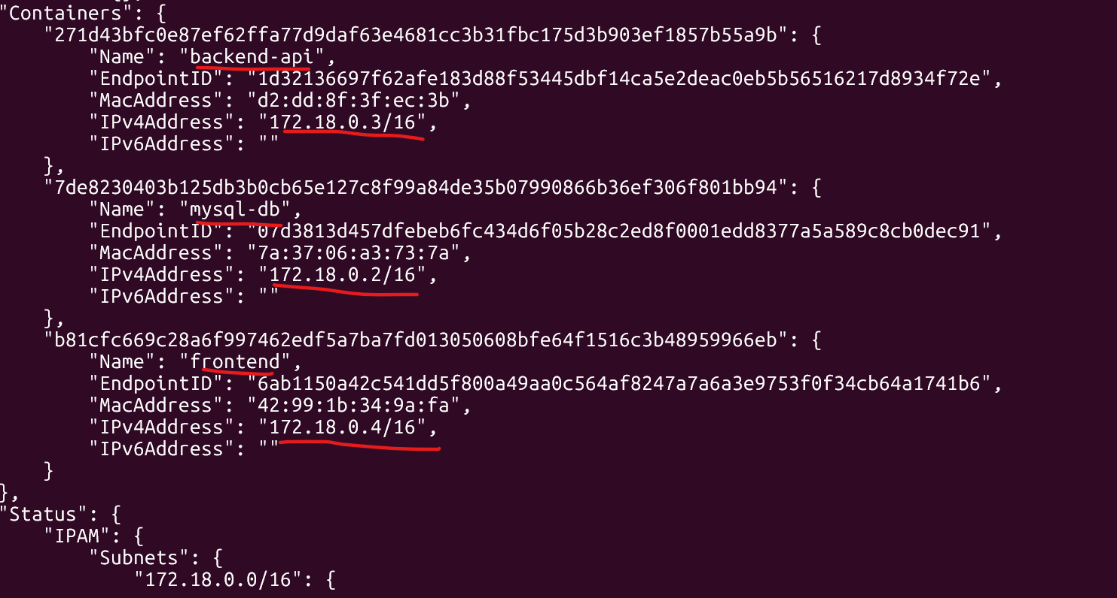
J – Storage check and connectivity
# docker volume inspect mysql-data
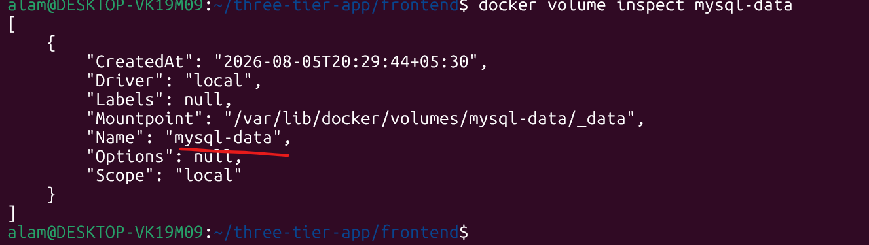
K – Check Backend DB and connectivity
$docker exec -it backend-api bash
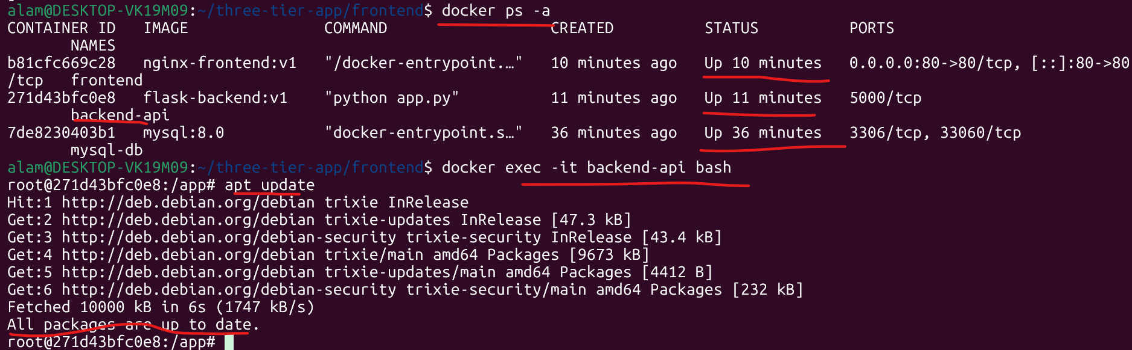

# Ping database
$ apt install iputils-ping -y ---- to install ping, first update the os, apt update
$ping mysql-db
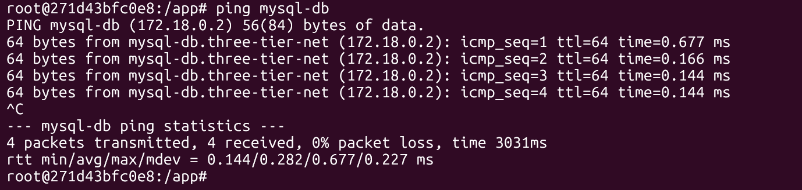
$ python
$ import mysql.connector mysql.connector.connect( host="mysql-db", user="admin", password="admin123", database="employee_db") ---- no error means it fine
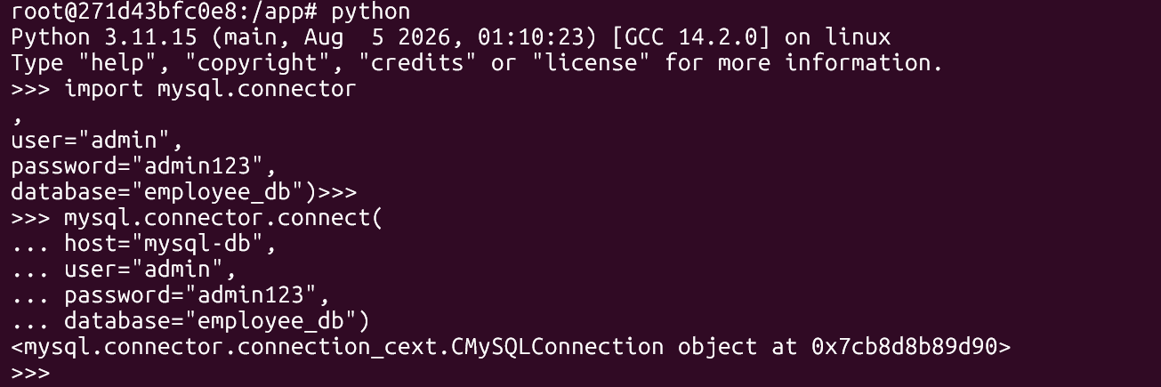

Backend IP :- 172.18.0.3
L- Verify Frontend → Backend --- donfirm db, and backend connectivity is ok.
$docker exec -it frontend bash -- login to frontend
$ ping mysql-db ---- db connectivity check from frontend
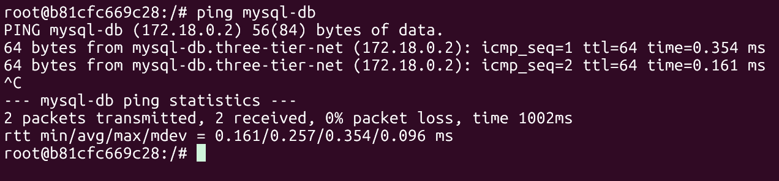
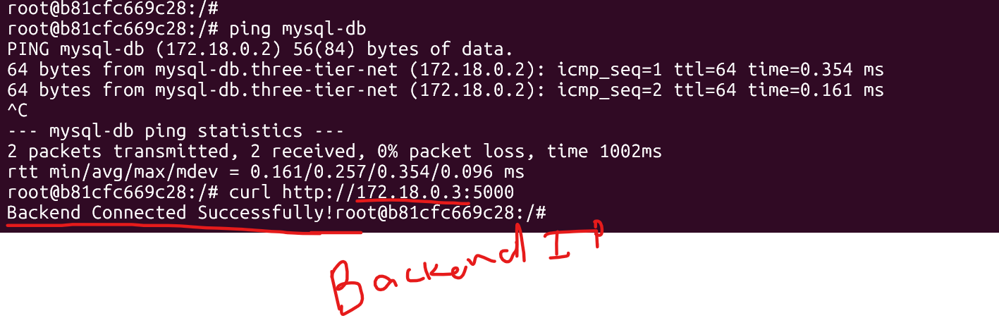
donfirm db, and backend connectivity is ok.

#Docker Over all all the service health check with
#Docker ps -- as below.
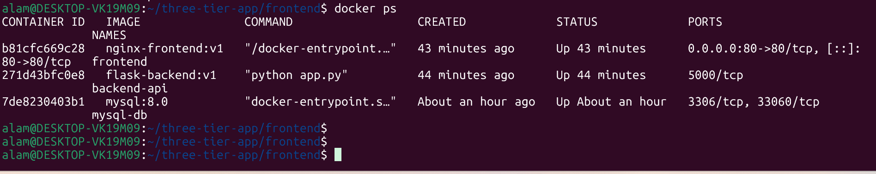
================================================================
Overall projects overviews.
Environment Variables -- used during mysql_db --- image creation
Pass all configuration through -e options, for example:
-e DB_HOST=mysql-db
-e DB_USER=admin
-e DB_PASSWORD=admin123
-e DB_NAME=employee_db

Service Dependencies
Without Docker Compose, Docker does not wait for dependent services. Start containers in this order:
- MySQL
- Wait until MySQL is healthy (docker ps or docker inspect). To debug if needed
- Backend
- Verify backend is healthy.
- Frontend

Troubleshooting

Frontend → Backend
docker exec -it frontend sh
curl http://backend-api:5000
If it fails:
- Verify both containers are on three-tier-net: --- on same network
docker network inspect three-tier-net --- network debug
- Check backend logs:
docker logs backend-api -- backedn-api debug
- Confirm Nginx proxy configuration:
docker exec -it frontend nginx -t -- debug and check the frnt

Backend → Database
docker exec -it backend-api bash
Test connectivity:
ping mysql-db
If it fails:
- Check MySQL logs:
docker logs mysql-db
- Verify the database container is healthy:
docker inspect --format='{{.State.Health.Status}}' mysql-db

Make sure credentials and database name match the environment variables.

